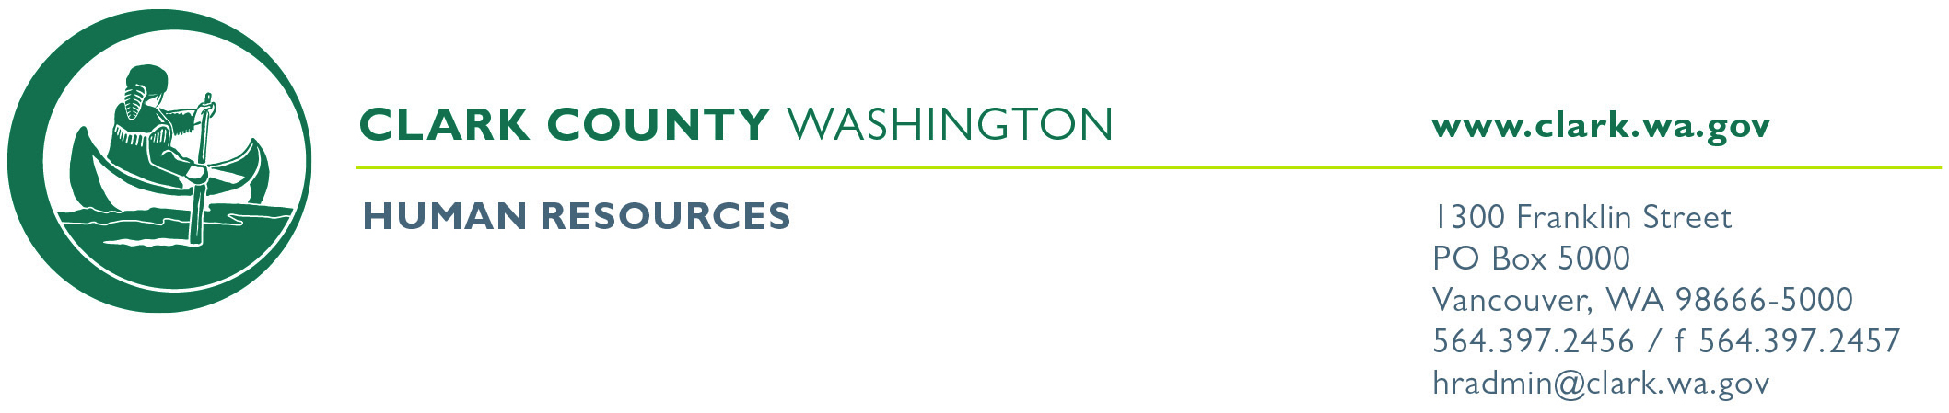
: Clark County Civil Service Commission Meeting

In Attendance

Commissioner Marla Ludolph-Heikkala (Chair)
Commissioner Crystal Kroeller (Vice Chair)
Commissioner Leah Anaya
Commissioner Garry Presthus
Commissioner Colette Draper
Senior Deputy Prosecuting Attorney Christine Cook (Counsel to the commission)
Secretary/Chief Examiner Leslie Harrington Smith

Meeting Date: Thursday May 16, 2024 Regular Meeting
Meeting Time: 3:00 P.M. Special Meeting

Location: This meeting will take place IN PERSON and via Microsoft Teams.
Conf Rm. 511 Conf Rm. 523 Conf Rm. 433
CCSO Admin Classroom Conference Call
Microsoft Teams meeting LINK: Join the meeting now
(Phone Number +1 213-262-7043 Phone Conference ID: 725 848 76#)

EXECUTIVE SESSION:

Commission may discuss personnel issues in Executive Session, with respect to RCW 42.30.110(1)(g) regarding Items #1 and #2 on the agenda.

REGULAR SESSION:

- Commissioners to review and act on the following background investigations submitted for certification:

Brothers, Joelle –Sheriff’s Support Specialist II
Casetta Stubs, Damon – Deputy Sheriff
Foster, Daniela – Sheriff’s Support Specialist II
Kristell, Timeree – Sheriff’s Support Specialist II
McCauley, Jacob – Sheriff’s Support Specialist II
McElveny, Samantha – Sheriff’s Support Specialist II
Miller, Tara – Sheriff’s Support Specialist II
Windon, Athena – Sheriff’s Support Specialist II
Barry, Emilie - Support Specialist II

- Commissioners to review and confirm the following background investigations for removal:
Lowell, Nicholas –Deputy Sheriff
Millier, Dawniel –Sheriff’s Support Specialist II
Starnes, Nathan –Deputy Sheriff

- Commissioners to review and certify the following eligibility lists for 12 months or until exhausted:

Deputy Sheriff R003042 May 2024
HR Representative R002906 May 2024

- Commission to review and approve the following meeting minutes:

April 18, 2024 Regular Meeting Minutes

- Other business to come before the Commission:

Next regular meeting is scheduled for Thursday June 20, 2024, at 3PM
Commissioners may confirm attendance:
Commissioner Marla Ludolph-Heikkala
Commissioner Crystal Kroeller
Commissioner Leah Anaya
Commissioner Garry Presthus
Commissioner Colette Draper

